

**FOR IMMEDIATE RELEASE**

**Finalists announced for the Recycling Innovators Forum**

*Tuesday, April 30, 2013*

Portland, Oregon -- Out of nearly 50 proposals submitted, nine finalists have been selected to compete in the 2013 Recycling Innovators Forum.

Sponsored by Alcoa, The American Chemistry Council's Plastics Division, Coca-Cola Recycling, eCullet, Resource Recycling, Inc. and Waste Management, Inc., the inaugural Recycling Innovators Forum seeks to recognize and reward original and actionable innovations that have the potential to transform the recycling industry. The Forum has long-term goals of fostering invention, originality and measurable improvement in recycling customer experiences, processes, technology and markets. The nine finalists offer promising and innovative ideas covering a broad range of topics including plastics sortation and processing, new opportunities for recycled glass, multi-family recycling, social-local-mobile technology and more.

Finalists will present their ideas to a panel of judges and an audience of recycling professionals, venture capitalists and clean-tech investors on the afternoon of August 26 at the Louisville Convention Center in Louisville, Kentucky. The judges, recognized leaders in recycling and business development, will choose three top finalists who will share $27,000 in prizes. In addition to cash prizes, finalists will also receive assistance from investor contacts in developing exceptional business plans and their ideas will be published in highly regarded trade publications. The Recycling Innovators Forum is free and open to the public.

More information about the Recycling Innovators Forum, including details about the nine innovative ideas selected as finalists, can be found online at [**http://recyclinginnovators.com/**](http://recyclinginnovators.com/).

**Contact**

Ali Briggs-Ungerer

Conference and Editorial Associate

ali@resource-recycling.com

**About Waste Management**

Waste Management, Inc., based in Houston, Texas, is the leading provider of comprehensive environmental solutions in North America. Through its subsidiaries, the company provides collection, transfer, recycling and resource recovery and disposal services. It is one of the largest residential recyclers and also a leading developer, operator and owner of waste-to-energy and landfill gas-to-energy facilities in the U.S. The company’s customers include residential, commercial, industrial and municipal customers throughout North America. To learn more information about Waste Management visit [www.wm.com](http://www.wm.com/) or[www.thinkgreen.com.](http://www.thinkgreen.com.)

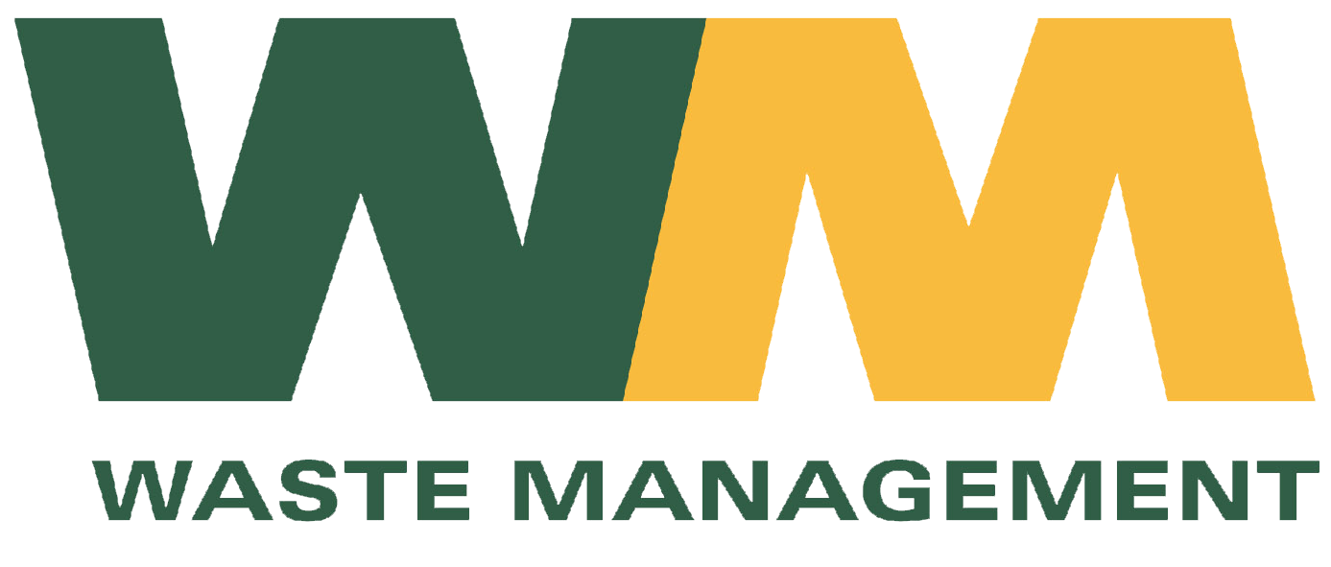

**About American Chemistry Council Plastics Division**

The American Chemistry Council’s Plastics Division represents leading companies dedicated to providing innovative solutions to the challenges of today and tomorrow through plastics. Ongoing innovations from America’s Plastics Makers have led to medical advances and safety equipment that make our lives better, healthier and safer every day. And, advances in plastics are helping Americans save energy, reduce greenhouse gas emissions and decrease waste. Because plastics are such a valuable resource, the Plastics Division is leading efforts to “reduce, reuse, recycle and recover,” including through outreach, education and access to advances in recycling technology.

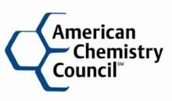

**About Resource Recycling**

Resource Recycling, Inc. has been an independent source of recycling news, information and resources for over 30 years. Headquartered in Portland, Oregon, the company’s publications include *Resource Recycling*, *E-Scrap News* and *Plastics Recycling Update*. The company also hosts and sponsors the annual Resource Recycling Conference, E-Scrap Conference and Plastics Recycling Conference. Visit [www.resource-recycling.com](http://www.resource-recycling.com) for more.

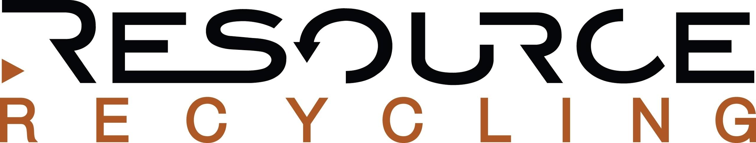

**About Coca-Cola Recycling LLC**

Coca-Cola Recycling LLC, a subsidiary of Coca-Cola Refreshments, is dedicated to recovering and recycling packaging materials used in North America - including polyethylene terephthalate (PET) plastic, aluminum, cardboard and plastic film. Coca-Cola Recycling is working to recover and recycle the equivalent of 100 percent of the packaging produced by the Coca-Cola system in North America. For more information, please visit [www.cokerecycling.com](http://www.cokerecycling.com/).



**About eCullet**

Committed to continuously perfecting its glass processing technology and operations to help promote a cleaner and safer environment, eCullet provides customers with the highest quality recycled glass to maximize the diversion of post-consumer waste from landfill. Through its collaborative partnerships, eCullet helps glass container manufacturers reduce greenhouse gas emissions, decrease energy consumption and preserve natural resources while helping our suppliers divert glass residue away from the landfill.

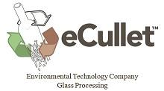

**About Alcoa**  
Alcoa is the world's leading producer of primary and fabricated aluminum, as well as the world's largest miner of bauxite and refiner of alumina. In addition to inventing the modern-day aluminum industry, Alcoa innovation has been behind major milestones in the aerospace, automotive, packaging, building and construction, commercial transportation, consumer electronics and industrial markets over the past 120 years. Among the solutions Alcoa markets are flat-rolled products, hard alloy extrusions, and forgings, as well as Alcoa wheels, fastening systems, precision and investment castings, and building systems in addition to its expertise in other light metals such as titanium and nickel-based super alloys. Sustainability is an integral part of Alcoa's operating practices and the product design and engineering it provides to customers. Alcoa has been a member of the Dow Jones Sustainability Index for 11 consecutive years and approximately 75 percent of all of the aluminum ever produced since 1888 is still in active use today. Alcoa employs approximately 61,000 people in 31 countries across the world. More information can be found at[www.alcoa.com.](http://www.alcoa.com.)

