

Materials Manager 4.4.0
Product Description

Contents

Contents 2
Product Overview 3
Functional Description 4
Scale Receiving Functions 5
Purchasing Management 9
Purchase and Sales, Contract And Pricing Functions 10
Freight Functions 11
Dispatch And Container Management Functions 13
Brokerage Functions 14
Inventory Functions 15
Production And Processing Functions 16
Batch Control Functions 17
Payment And Accounting Functions 18
Sales Functions 19
Security and Audit Functions 20
Formula Pricing 21
MRP Processing. 22

Product Overview
Materials Manager is a complete "scale to scale" management solution for recycling companies and steel mills.
The prominent features of Materials Manager are:
- Complete multi-currency support
- Complete multi-unit of measure support
- Supports multiple sites and multiple companies in the same database
- Comprehensive "active" reporting facilities allow the user to drill down from a Corporate summary right down to individual scale weighing
- Client server development supports open database platforms such as Microsoft SQL Server, Oracle, Sybase, etc.
- Easy to use Windows interface
- Integration with other Windows applications such as Microsoft Word and Microsoft Excel
- Integration to various accounting systems
- Stand alone Scale operation ensures your scales are still running even when your main server is down

Functional Description
The following functional description pages describe each module within the application in turn. In reality the application appears to the user as one seamless software solution and is shipped to the customer as one package. The following pages describe each functional module, broken down into the following sections:
- Scale receiving and dispatching
- Purchasing functions
- Contract and pricing functions
- Freight functions
- Dispatch and container management functions
- Brokerage functions
- Inventory functions
- Production and processing functions
- Batch control functions
- Payment and accounting functions
- Sales functions
- Billing functions
- Security and audit functions
- Formula pricing
- MRP
- Inter Branch Transfers

Scale Receiving Functions
- Built in resilience through off-line data store. Keeps scale running and collecting valuable information even while main systems are off-line.
- Handles sales and purchase transactions
- Single or multi-stage process.
- Multiple weighing.
- On site or "in queue" vehicle listing ability.
- Unlimited commodities per transaction.
- Track able, independent vendor descriptions for each commodity line.
- Allows both account and non-account transactions for large vendors and "one-off" peddler trade.
- Manual or automatic price entry, contract or no-contract.
- Allows weight or amount deductions per commodity line.
- Easy to use windows interface.
- Single key searching for vendors, customers, freight carriers, commodities and contracts.
- Option of linking directly to scale for direct interface of scale weighing, no manual weights entered.
- Multi-line or grades per transaction.
- Eliminates mistakes and possible fraud.
- Keyboard optimized for fast data input. Account transaction can be entered and completed with only 4 fields entered by the operator.
- Live, real-time or delayed information.
- Full event log per transaction, identifies changes and strange events.
- Fast cutting of checks for materials, freight and other services right at the scale
- Creates full documentation including purchase and sale tickets and inspection documents
- All produced documents i.e. tickets, bills of lading etc. customizable by the customer using Crystal Reports
- Public weighing
- Supports movements between piles/locations
- Supports material sorting from a delivery load or from a pile
- Baling function to weigh, tag and transfer material from unprocessed to finished inventory
- Automatically creates transfer records for inter-branch movements. The receiving branch has the transaction in their scale program prior to the arrival of the truck.

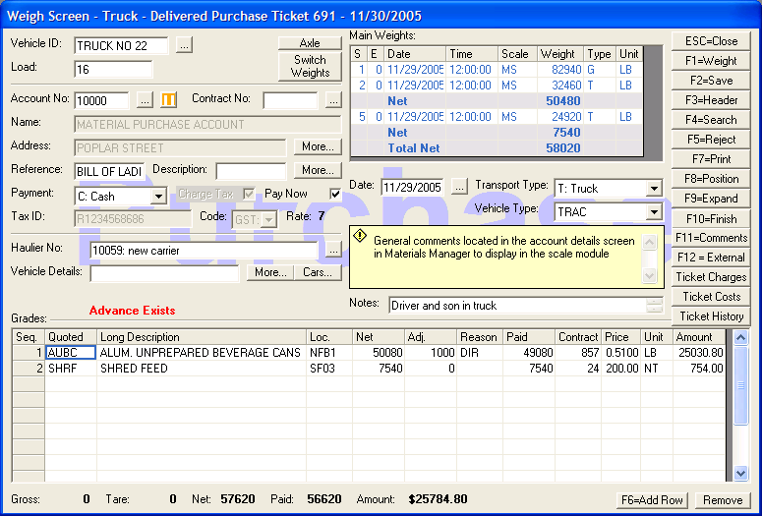

Touch Screen – Screen Shots
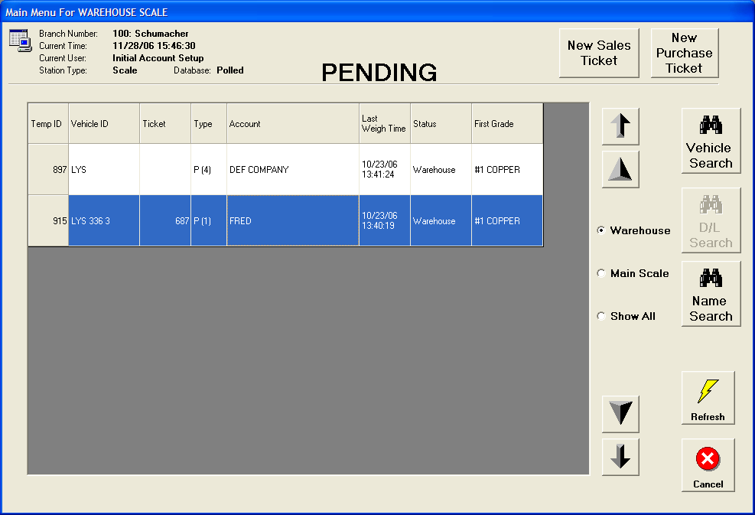

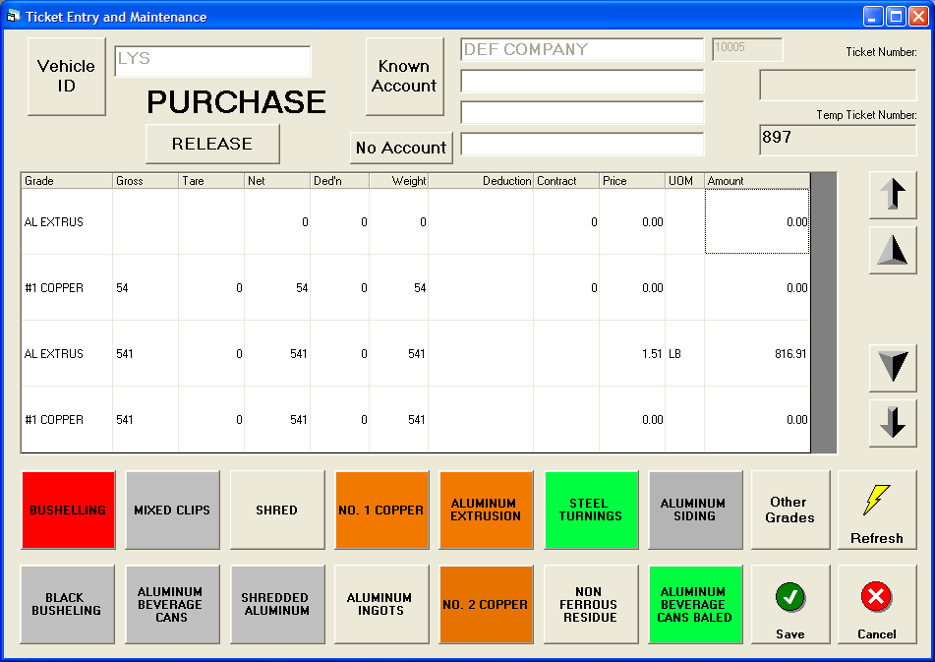

Purchasing Management
- Real-time tracking of purchases and deliveries across companies.
- Automated price and contract allocation.
- Automated freight cost allocation
- Multiple payees per transaction
- Multiple charges per transaction i.e. freight, dead freight, agency costs, plant hire etc. etc.
- Comprehensive operational reporting - by commodity, vendor, day, month, buyer etc. etc.
- Drill down from top level summaries right down to scale weighing.
- Full audit tracking of all changes to transactions
- Intelligent fraud tracking reporting
- Interface to company's accounts payable applications
- Analyze vendor performance including waste or deductions made, delivery frequency and quality.
- Comprehensive searching facilities.
- Payment based on vendor or internal (scale) weights.
- Automatic dead freight calculations.
- Automatic contract position update.
- Ability to handle "one of" deals through individually priced transactions without contracts or vendor setup.
- On screen reporting eliminates reams of printed reports.

Purchase and Sales Contract and Pricing Functions
- Easy to use contract management facilities.
- Can handle contracts and basic pricing information.
- Contract and price management by buyer, vendor, location, commodity etc. etc.
- Multiple search and sort criteria.
- Easy contract and price setup through enhanced duplication and block change facilities.
- Full contract printing facilities.
- Automatic tracking of contract position.
- Quotation and conversion to active contract.
- Multiple charges and costs allocation per contract.
- Automatic completion of contracts.
- Ability to roll-over contracts automatically into new months until fulfilled.
- Automatic allocation to transactions.
- Automatic update of transaction on changing of contracts and/or prices. No need to manually adjust individual transactions.
- Unlimited internal and external comments.
- Stored comments facility for commonly used comments.
- Vendor and customer profile information for management of contacts, pricing etc. etc.
- Multiple modes of shipment per each contract.
- Level based pricing system for simpler price management
- Formula pricing for management of market based contracts or pricing levels.
- Alternate grade description for each commodity on the contract.

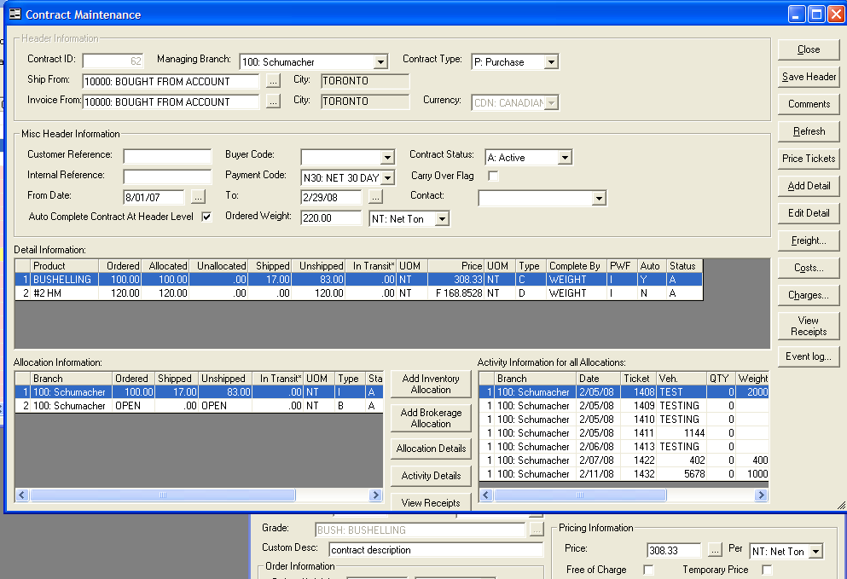

Freight Functions
- Full freight rate database.
- Automatic or manual allocation of freight rates to contracts.
- Automatic allocation of freight costs incurred to transactions.
- Accurate freight accruals. · Support for multiple leg (Rule 11) rail freight contracts.
- Zone and Routing database.
- Fuel Surcharges

Dispatch and Container Management Functions
- Full vehicle analysis facilities
- Inventory of bins and containers
- Tracking of container usage
- Tracking of container location
- Quickly establish whether containers are profitable
- Exception reporting shows lost or long outstanding container pickups
- Integrated with receiving and dispatch facilities for easy update of container placements and returns
- Dispatch facilities allow management of dispatch requests and on-screen planning of drivers, trucks, trailers, containers etc.
- Integrated map facilities for enhanced driver directions and street maps
- Multitude of reports such as driver instructions, planning and activities all with drill-down analysis and on screen inquiry.

Brokerage Functions
- Single entry screen for brokerage transactions
- Application allows multiple purchase contracts to be linked to a single sales contracts
- Accurate contract position reporting shows quickly what material is needed.
- Tracking of deliveries against contracts identifies performance and gross margin
- Enter shipped weights and settled weights at time of entry or separately depending on when information is received.

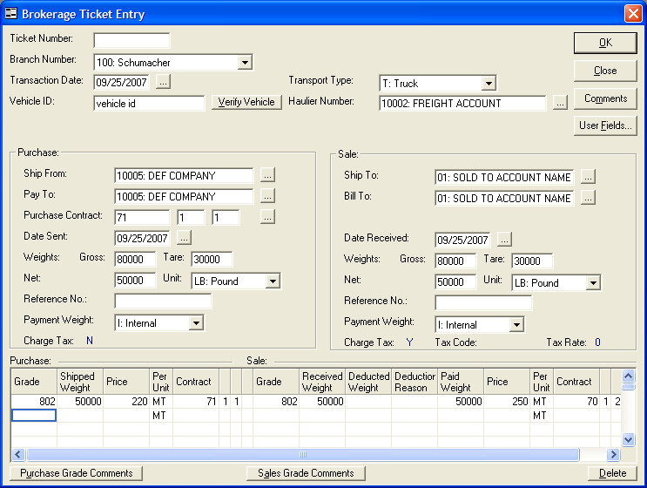

Inventory Functions
- Online average cost calculations
- Perpetual inventory
- Multiple inventory views i.e. total company, by branch, grade, month or daily
- Comprehensive "drill down" facilities
- Supports multiple commodities, locations, piles and pile groups
- Month end closing processing
- Easy entry and tracking of inventory movements and re-grades
- Separate entry for adjustments i.e. write ups or write offs
- Integrated production facilities keep track of un-processed material
- Separate production entry for "explosion" style processing.

Production and Processing Functions
- Separate production facilities keep track of processing by plant.
- Reporting by raw material, finished grade, plant, site and period.
- Keeps track of availability, plant performance and delay information.
- Track individual shifts
- Compare performance across plants

Batch Control Functions
- Ability to create batches for tracking of all inventory transactions.
- Automatic allocation of tickets to correct batch via contract.
- Tracks all inventory activity for each batch including movements, re-grades, production, adjustments etc. etc.
- Provides facilities for viewing material still left to process, finished material and recovered (metallic) weights.
- Summarized and detailed activity reporting

Payment and Accounting Functions
- Multiple payees per transaction.
- Online invoice matching for material, freight and other associated bills.
- Multiple methods of payment.
- Cash management facilities for improved site cash control.
- Interfacing into companies accounts receivable and accounts payable applications.
- Self-billing facility for automated processing of transactions.
- Full tax handling support.
- Easy to use settlement functions, reporting and billing

Sales Functions
- Real time tracking of sales and deliveries across companies.
- Automated price and contract allocation.
- Automated freight cost allocation
- Multiple payees per transaction
- Multiple charges per transaction i.e. freight, dead freight, agency costs, plant hire etc. etc.
- Comprehensive operational reporting - by commodity, vendor, day, month, salesman etc. etc. · Drill down from top level summaries right down to scale weighing.
- Full audit tracking of all changes to transactions
- Intelligent fraud tracking reporting
- Interface to company's accounts receivable applications
- Analyze customer performance including waste or deductions made, delivery frequency and quality.
- Comprehensive searching facilities.
- Payment based on vendor or internal (scale) weights.
- Management facilities for tracking settled weights.
- Automatic contract position update Billing Functions
- Automated processing of sales invoices
- Automatic allocation of GL Accounts to invoice detail lines.
- Interface to companies accounts receivable applications.
- Fully customizable invoice format

Security and Audit Functions
- Comprehensive security facilities by function and user action i.e. Add, Change etc. etc.
- Limit user actions to functional area, company, site or even commodity group
- Integrated security management facilities
- Tracking of unauthorized access events
- Full tracking of all events throughout the system from minor events to more major events such as price changes · Summarized reporting allows quick identification of possible problems
- Tracking of application errors to aid in system administration
- Intelligent reporting helps pinpoint fraudulent activity
- Security profiles allows for departmental securities to be allocated to all associated users.

Formula Pricing
- Management and history of market pricing
- Link contracts or vendor/customer prices to formula based on selection of high/low/average market price plus variance (+/-)
- Automatic pricing of past transactions when entering market prices mid-month or after deliveries/shipments have occurred.

M.R.P. Processing

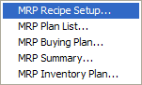

- Material Requirements Processing
- Melting Recipes
- Monthly Melting Plans
- Summaries of Inventory and Required Purchases for Melt Plan
- Projected month end inventory positions
- Takes into account in-Transit Shipments, Inventory, and Purchase Orders

