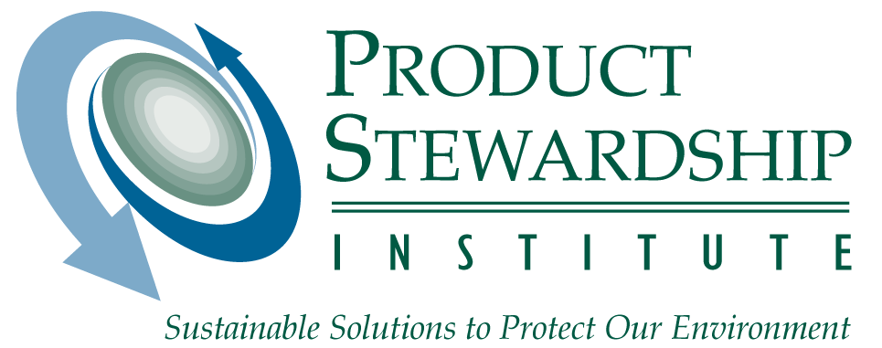

March 14, 2008

Tracy Varghese/Jonathan Birdsong, Rep. Mike Thompson’s Office
Greg Regan, Rep. Louise Slaughter’s Office
Caroline Ahearn, Rep. Albert Wynn’s Office
Chris Foster, Rep. Mary Bono Mack’s Office
Greg McIlvaine, Rep. Zach Wamp’s Office
Dave Berick, Sen. Ron Wyden’s Office
Joel Merkel and Michael Daum, Sen. Maria Cantwell’s Office
Chris Slevin and David Hodapp, Sen. Sherrod Brown’s Office

Dear Congressional Staff:

Thank you for the opportunity to comment on the E-Recycling Concept Paper. The Product Stewardship Institute, Inc. (PSI) has worked on the issue of electronics scrap management at the national and state levels for the past eight years. This proposal represents a significant step toward developing a national program. As PSI membership includes 43 states and over 50 local governments, our organization has a keen interest in ensuring that all states have a scrap electronics reuse and recycling program. PSI offers the following comments as a way to achieve consensus on the proposal.

Disposal Ban
PSI recommends that the ban on the disposal of covered electronic devices (CEDs) not specify the type of disposal; it should include incinerators since there is no energy value to incineration, and reuse and recycling are higher on the hierarchy of waste management. Some states believe that a disposal ban should become effective immediately upon program enactment, while others believe it should become effective a few years after program enactment so that program partners have time to set up the recycling infrastructure. In any case, if a state has a law with a disposal ban sooner than the federal requirement, it should not be pre-empted. I will explore this issue further with government officials.

RCRA
Many state and local officials expressed concern about this provision, which would result in their agencies losing regulatory authority over electronics scrap recyclers who, in the past, have left warehouses of scrap equipment for the state to clean up. PSI recommends that EPA add electronics to the federal Universal Waste Rule so that it would be treated as a hazardous waste unless intended for recycling.

Extended Producer Responsibility (EPR)
Eight years ago, at the start of stakeholder negotiations on the electronics issue, state and local government agencies unanimously preferred an EPR approach that covered the full costs of collection, transportation, reuse, and recycling. It took about six years for that approach to finally take hold in state electronics management laws. These agencies interpret the term “shared responsibility” to refer to the different roles that each stakeholder (including government) must assume in order for a program to be successful. However, government agencies, in general, believe that the financial burden of managing electronic scrap should be covered by manufacturers (or retailers-as-manufacturers), even if these costs are later recovered from consumers. It is also crucial that consumers experience the collection programs as “free,” since charging consumers an end-of-life fee to manage their scrap electronics will encourage illegal dumping. We may even find that, in addition to providing incentives to manufacturers and retailers-as-manufacturers, citizens will also need incentives to recycle. Making the program no-cost is a good starting point.

Recycling Requirements and Export
Many recyclers are exemplary in their handling of scrap electronics. However, many are not. State and local agencies want to create a level playing field for all recyclers so that those that safely manage electronics in the U.S. and abroad are held to the same high standards. It is unfair for recyclers following high standards to be at a competitive disadvantage, and the environmental and health impacts from poor recycling practices experienced in some developing countries are all too evident. We all become responsible for the problems created if scrupulous business practices are not followed. States do not have authority to address the export issue and need federal legislation. PSI appreciates the attention paid to this issue in the concept paper, and we encourage you to continue to find ways to strengthen these sections of the legislation. The implementation of federal best management practices (BMPs), as outlined in the concept proposal, will help, especially if it includes strong auditing of processing facilities to ensure that all recycling facilities are meeting the same BMPs. The concept of an Advisory Panel (see “Other” at the end of this letter) could be a valuable tool for improving these requirements over time. This panel would be able to provide input for revisions to the requirements so that they are still effective when handling new types of electronics equipment or addressing new problems in global recycling activities.

Federal Performance Requirements
Performance targets are one of the most important aspects in any product stewardship program. These goals should be aggressive. PSI strongly supports this section and believes that numerical targets should be the cornerstone of the program and will be the only way to measure performance and progress. Without numerical targets based on a percentage of scrap electronics available for recycling, terms such as “reasonably available,” “reasonably achievable,” and “certify as effective” will be focal points for contention. These terms are only surrogates for the bottom line – the percentage of equipment we want to collect, reuse, and recycle. PSI believes that the initial implementation period for which fee-based penalties would not apply should be limited, possibly to two years. During this interim period, the terms above should be defined as clearly as possible.

Government officials have expressed concern that, unless a strong set of standards is included in the legislation, the Congressional model being discussed would result in uneven delivery of physical collection services to the public and thus result in an under-performing system. The language in the model states that “…a CED recycling program could include one or more of the following elements or other elements that the manufacturer can certify as effective in meeting plan goals.” Two of the four methods (see points below) allow for no permanent infrastructure to be made available to the public, and the remaining two are vague on that point:
- Manufacturer take-back of its own branded devices by any means selected by the manufacturer; this may include direct mail-back, collection events, retail store collection points, etc.
- Manufacturer sponsored collection events for any brands.
- Manufacturer coalition (or manufacturer groups) sponsored collection programs for any brands.
- Manufacturer financial support for local government collection programs for any brands.

For the federal program to develop some semblance of consistency (e.g., for states to defer to the federal program), it will need to include strong collection, reuse, and recycling targets that require continual improvement and, in the interim, to include stronger requirements pertaining to the development of physical infrastructure.

PSI agrees that EPA should review and approve manufacturer plans for reaching their allotted targets, and that, if these targets are not met, EPA should have the ability to require additional actions in order to meet the targets. Under the section “Manufacturers and Retailers-as-Manufacturers,” it states that manufacturer programs must meet qualitative performance requirements, but says nothing of the percentage-based requirements under the “Performance Requirements” section. This should be edited for consistency. PSI also supports the requirement that manufacturers submit data annually on CEDs sold, recovered, and recycled, although reuse also needs to be added. In addition, the stakeholder group should explore whether states should be allowed to set goals higher than whatever goals are developed by EPA. This approach to setting performance goals is what states and the paint industry are exploring regarding a national system for the collection, reuse, and recycling of leftover architectural paint, which is another PSI project.

Registration Fees
It is appropriate for registration fees to cover the cost of program administration and enforcement, but not to cover the cost of electronics scrap management. Management costs should be covered by manufacturers. Increasing fees for under-performing programs, as is proposed, will provide an incentive for recycling, which we support. However, the increase in fees will need to be high enough so that it serves as a real penalty that will encourage recycling and program development and not become just another minor cost of doing business. Reduced registration fees for reuse (or some other incentive) should also be incorporated.

State Authorization
This issue was very important to state and local government officials, and they have asked what specific responsibilities authorized states would have to assume. Some officials believed that the process seemed cumbersome. They asked whether, if states need to have a role in enforcement and administration of federal requirements, this could be managed through interagency agreements or something less formal than state authorization. Others were perplexed that a producer-run program would need much government involvement at all, since the idea behind this model is that government sets targets, participates in planning, and conducts enforcement, but gets out of the way of industry so that it can run an efficient program. In any case, they were very concerned about whether the costs for them to perform their functions would be covered by the registration fees.

The best way to convey the comments by state officials is to provide a few of them verbatim.

Frankly, it is not really possible to manage new duties without a funding mechanism, and many states find it very difficult to get support for new fees at the state level. At this time, [our program] is already trying to solve the funding problems in order to continue some of its current activities. Funding is a necessity concerning this program. No state can afford to run such a program without sufficient monies.

Given the nightmare that we went through with RCRA Subtitle C authorization, I think that it is imperative that the legislation be very clear about a most streamlined process. I don’t want to waste money and other resources.

The issue is…will manufacturers pay, through whatever fees are set up, enough money to cover the cost of states to get authorized (there are administrative burdens on states to do this process).

I am perplexed /confused by the Concept Proposal – under producer responsibility, all “program” costs are paid by the manufacturers (excepting maybe some promotion and education). There really should not be any talk of “federal grants”… Producer responsibility is all about producer financed systems…high targets with lean government oversight.

State Role/Preemption
PSI strongly supports the provision stating that existing state laws will not be preempted, and that states can adopt and enforce any regulation, requirement, or standard of performance with respect to the management and recycling of CEDs that is more stringent than the federal program. Under “Governance,” however, the following sentence was cryptic: “Certain preexisting state laws would sunset once federal legislation is enacted.” What laws were you considering being preempted? For states to consider joining the federal program, it will need to include high standards. The higher the standards, the more that states will be compelled to join the federal program.

Covered Electronic Devices (CEDs) and Scope
PSI supports the ability of EPA to expand the scope of CEDs. However, the criteria for adding products should include product lifecycle impacts in the definition of “environmental risk.” Many non-toxic materials, such as paper and plastics have high lifecycle impacts (including greenhouse gas emissions), which will translate their reduction, reuse, and recycling into environmental gains. Commodity value is a weaker criterion than “current reuse and recycling rate.” If a product has a high commodity value, the chances are that it will be recovered in high volume. However, that is not always the case. Candidate products should include those for which high reuse and recycling rates are not being achieved, and for which there is great customer demand.

Credits and Incentives
The incorporation of credits and incentives for collecting qualified products, other brands, orphan products, and achieving high performance is a creative way to encourage recycling. Increasing scaleable fees for low performers is also supported. However, state and local agencies were a bit confused by the “Green Seal” label, although they would like to explore the concept further. Note that Green Seal is the name of a certification company that licenses the use of its seal if its consensus-based standards are met through verification. One consideration is whether the current EPEAT program is enough of a design driver, and whether the potential for reduced registration fees is enough of a recycling driver. Any label program will be administratively complex for EPA to run.

Regarding input sought on the reconciliation of state and federal fees, PSI suggests that, although the concept that states with their own fee structure would receive less federal funding sounds fair, in some situations it could downgrade the level of effort being conducted in that state. A state may have a more comprehensive program than what is adopted at the federal level and may need the flexibility to use its established funding as needed.

Sunset Provision
PSI recognizes that some entities believe that recycling markets will drive the commodity value of electronics to a point where the law will no longer be needed to encourage recycling. PSI finds this assumption to be untested. Even products such as aluminum, with a high commodity value, are recycled at a rate under 65 percent. Instead of a 15 year sunset provision, PSI suggests that the current proposed Congressional requirement that EPA recommend any program changes after 15 years be sufficient. If a program phase-out is advisable, EPA can recommend that Congress take such action.

Definitions
- Do “consumers” include large businesses, institutions, and government, or is it intended to just mean households and small businesses?
- Special treatment for “small manufacturers” with less than a certain percentage of market share seems advisable. However, what responsibility is there for a manufacturer that falls into this category today but which has their brand of scrap electronics in the recycling stream and is still a viable business?

Other
A federal electronics management program will require continued collaboration among all stakeholders. PSI suggests that Congress require EPA to assemble a multi-stakeholder Advisory Panel to provide input to the Agency on an ongoing basis so that there will be a forum for lessons learned can be easily shared among states.

PSI offers to work with Congressional staff and other stakeholders to negotiate a viable solution that will be supported by the widest coalition. The higher the bar achieved by federal legislation, the less need states will feel to go beyond it, and the fewer variations there will be nationally, which will ultimately be simpler and less costly for industry to abide by.

Sincerely,
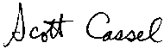

Scott Cassel

Executive Director/CEO

