DLUBAK Glass Co. Inc
11567 County Hwy 110
Upper Sandusky OH 43351
Ph: 419-294-4466
Fx: 419-294-1303
www.dlubak.com
‘Recycling at its Best since 1932’
July 31, 2026

Dear Valued Customer,

After an “Informal Conference” the morning of Oct 4th with the OSHA Region 5 Toledo OH Regional office personnel and the assistant Director, Dlubak and OSHA agreed to complete 3rd party Air and Audio testing in our two Upper Sandusky OH glass processing facilities and re-train personnel on personal hygiene in regards to working with Lead and Cadmium containing substances. This is to be completed by Nov 30, 2012, and is well on its way.

The warehouse, where OSHA fined these temporary operations, remains closed for any production activities.

In turn, OSHA during the Conference, agreed to declassify and abate the Violations, remove “willful” and reduce the fines.

At the end of the same day, Dlubak was notified that the OSHA Region 5 office in Chicago did not support the changes. As a result, Dlubak will continue to work with OSHA while going ahead with the solutions agreed to at the Informal Conference.

We thank you for your patience and your continued patronage.

Sincerely,

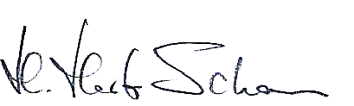

H. Herb Schall
Director

